Learning Python Day 1 – Notes

**Drawing a Shape** –

1. Various print statements needed to replicate shape.
2. Print statement helps user see what is going on with program by displaying it in console terminal. Whatever is in the speech marks within the print statement is displayed in console.

**Variables**

1. A variable is a container that is used to hold data variables and is used as data management.
2. Once again, data that is changed in the print statement will be displayed in the console terminal.
3. The variable name needs to be assigned in the container. Example “Character_Name”
4. After this, the first print statement will change to match assigned variable.
5. The value of the assigned variable will be retrieved to display features such as age and name. Example “John, 35”.
6. Names and age values can easily be changed in the assigned variable to change output of console.
7. Variables can be modified at any point. This will change the stories and value output in the terminal display.
8. A string data type refers to plain text whilst numerical data does not need quotation marks. Boolean value refers to a true or false value, Example is male.

**Working with Strings**

1. New lines can be inserted into the string by using (\n. This creates a line between text values in the terminal. Variable can also be created that ensures print statement refers to variable and its value.
2. Concatenation is the process of appending a string to an existing string. Whilst a function refers to a specific operation that can be performed on the program. Example: (phrase.lower()).
3. Is value can determine whether something is true or false. Example: isupper; False. print(phrase.upper().isupper()) can be used to return a true or false value based on whether it has been changed. The functions can be used one after another.
4. Length Functions can be used to determine how many numerical characters are contained within a string variable. Example: phrase = "Tottenham Hotspur"

print(len(phrase))

Length = 17

1. Individual characters can be obtained from a string by specifying the index. phrase = "Tottenham Hotspur"

print(phrase[3])

t

1. Passing a parameter refers to inserting the index string value which will be transferred into a number. Example: 

Value = 0

1. Replace function is used to replace one word with another by typing them in succession. 

Displayed in Terminal: Nothing Hotspur

**Working with Numbers**

1. Numerical equations can easily be performed in python. However, a parenthesis will have to be inserted to demonstrate the order of the mathematical equation. Example:



1. Modular operator is used to perform mathematical equations where a remainder will be present. Example:



1. Numbers can also be stored in variable containers with values. Example:



This converts a number value into a string value and also displays that 5 is my favourite number in the terminal.

1. abs refers to the absolute value of a number based on the declared variable value. Pow function gives two pieces of information which is the number itself as well as the power we want the number to go to. Example would be 4 to the power of 4 (4x4x4x4)



The max function returns the max (biggest number that has been passed into it) whilst the min returns the lower number. The round function returns a numerical value that is a decimal rounded up. Example: 3.9 would be rounded up to 4.

1. Additional math functions can be imported using: 

This is classed as external code. Floor and Ceil functions are similar to max and min as they return the lowest and highest values including decimal numbers. sqrt returns the square root of a number.

**Getting Input from Users**

1. The input function is telling users to enter information. Example:





Additional variables can be made that ask for other pieces of information such as age. Example:



**Building a Basic Calculator**

1. A basic program can be created that will act as a calculator. This will combine two number variables and print the result of the calculation in the corresponding terminal. However, a special python function needs to be used to change the string value into numbers. The integer function is converting whatever is in the parenthesis into whole integer numbers. Example:

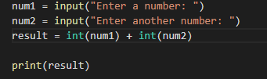



However, problems will arise with the program as the calculator is looking for integer values and not decimal numbers. The float function allows decimals to be entered so the calculation can be complete.

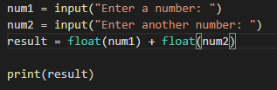



**Mad Libs Game**

1. A mad libs game can also be created with python that prompts the user to enter their own values to complete the mad libs game. Variables will need to be created to store user input, for the sake of the example it is three. Example:

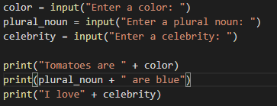

As displayed, the created variables are prompting the user to enter information whilst the print statements will display the value as well as the declared variable text, which is “Enter a color” etc.